Wax Museum

Dear Families,

This packet has the guidelines for the biography/Wax Museum project.

Your child will need to research on ______________________________________________________________.

After reading through this packet, please sign the last page and return it to school confirming knowledge of the project. If you have any further questions please contact your child’s teacher.

WAX MUSEUM DATE: November 28th, 2017. (Parents/grandparents etc… may come to the event between 8:45 – 10:30)

Components of the Project:
In School:
- Name of historical person approved.

- If extra time, students may work on research and components of their tri fold display.

- Presentation: Done on the day of the museum

At Home:

- Get Books or valid information from the Internet and send to school. The St. Clair Shores library is a great source for books. Try not to get huge books that will take your child too long to read. Select books that are at their level. The school Library may have a book but it’s not likely. The library is also a place to use computers and print information if you do not have them at home or work.

- Written speech

- Tri-fold presentation board.

- Practice Speech as if child has become their character. Talk like “George Washington” might have talked. (Memorize as much as possible. May use note cards to help.)

- Costume to wear during presentation. (Please don’t feel like you need to go out shopping for clothes. Just be creative! Ask friends and family to check the back of their closets etc. The Salvation Army /Thrift stores are also great sources for costume parts. This tends to be the most exciting part for the students! Props that sit on a table or can be held are also acceptable. (Baseball gloves, chemistry sets, etc… Items that fit your person.)

- Mark your calendars and please help keep your child on track. Don’t wait until the last minute. Staying on schedule is the secret to success.

Requirements

Research and Speech:

- Name of person, date of firth, place of birth, date of death if passed on and place of death.

- A famous quote to use as attention grabbing (hook) for the beginning of the speech.

- Family and Childhood Information.

- Major Accomplishments – Why the person is famous?

- How this person has impacted the lives of others? (This may be similar to the major accomplishment(s). (Awards, etc…)

- 10 nor more interesting information pieces or events such as difficulties in life, or other fun facts that will make your speech interesting.

(Students will be given an outline form to help with research and organization of this information.)

Tri-Fold Display Board:

Required Information Text Features

- Name of Person (Title) (Large, Stands Out etc…)

- Various Photos of person showing their life. Must have captions explaining the photo.

- Organization of poster by using Headings/Sub Headings. These should be mounted on construction paper. (Your teacher can provide this if needed.)

- A time line with the at least 8 events in the person’s life.

- A bulleted list of 10 interesting facts about the person.

- Bibliography for information used in project displayed on back of display board. (must use valid sites for information for example-no Wikipedia) If needed, see teacher for available sites.

Optional Information Text Features:

- Maps (Possibly of where they lived or traveled)

- Diagrams (If the person invented something, you may find a diagram labeling parts etc…

- Bold or Italic print to help important words stand out.

- Famous quotes that the person is known for.

Other Tri-Fold Display Requirements:

- Must be free-standing.

- All Writing should be typed if possible. If Hand Written, it must be extremely neat and presentable.

* Remember you can have the best report but if your display isn’t top notch, it will take away from the quality of your report.

Estimated Work Schedule

Entire 2Weeks: Famous Quotes, Time Line Information, & interesting facts.

November 8-15: Collect books and Internet articles to help with research. Start if able to do so.
(See examples of how to research and write a speech)

November 15-16: Research for parts 1 & 3 (Name, birth, family childhood etc…)

November 17-19: Research for parts 4 & 5 (Accomplishments, why famous etc…)

November 20-24: Speech Writing

November 27: Finish up anything not completed. (Make sure display is done or getting done and you practice your speech at home.

November 28th, 2017: Wax Museum

Grading
Scores/grades for this project will be as follows:

4 Exceptional, exceeds expectations
3 Proficient, meets expectations
2 Partially Proficient
1 Not Proficient

- Speech/presentation will be graded in the following categories: content, preparedness, posture and eye contact, costume, & props.

- Poster/Display will be grade based on the following: Title, bulleted facts, photos with captions, timeline, neatness/effort (headings & mounting), Spelling, capitalization, bibliography and other mechanical content.

*See Attached Rubric for detailed explanation on grading.
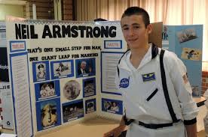
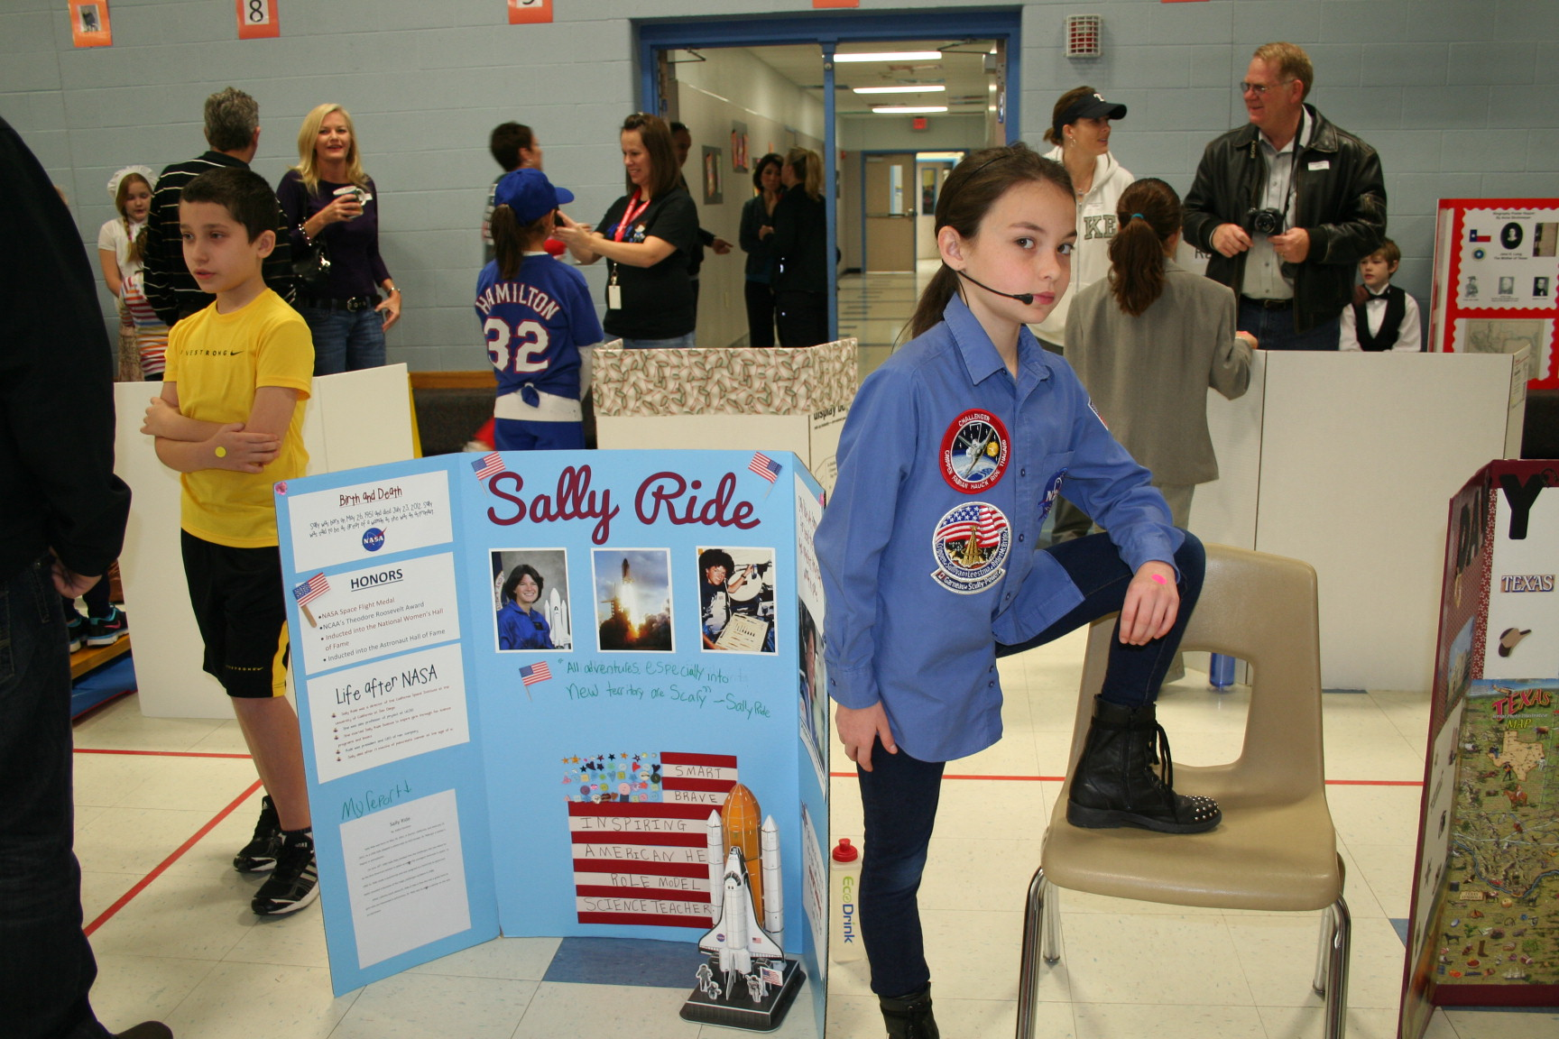

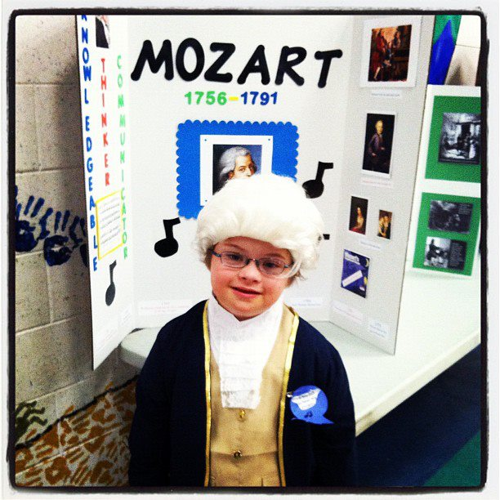
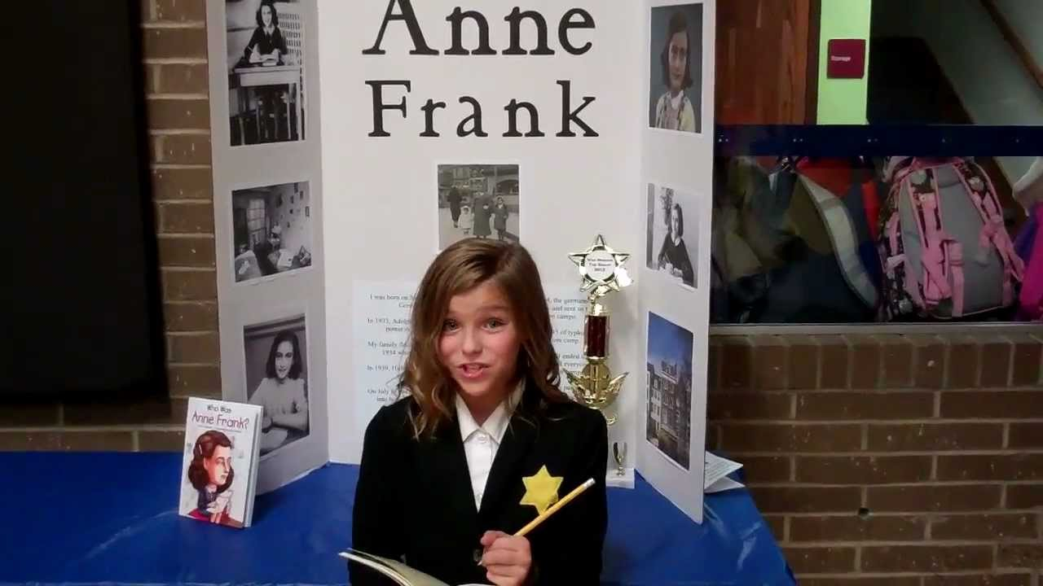

--------------------------------------------------Return Bottom------------------------------------------------

My child and I have read and discussed this project and understand the requirements and deadlines.

___________________________________________________ _________________
Parent Signature Date

____________________________________________________
Student Name

